BONUS Drawing Challenge #1
Using the spaces below draw a cake...not just any cake but a cake with at least 3 layers and covered in your favorite candies, decorations, hobbies, or whatever you would choose for a cake.
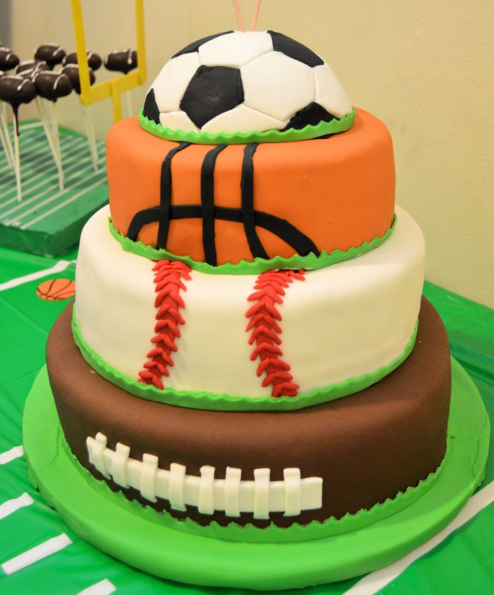
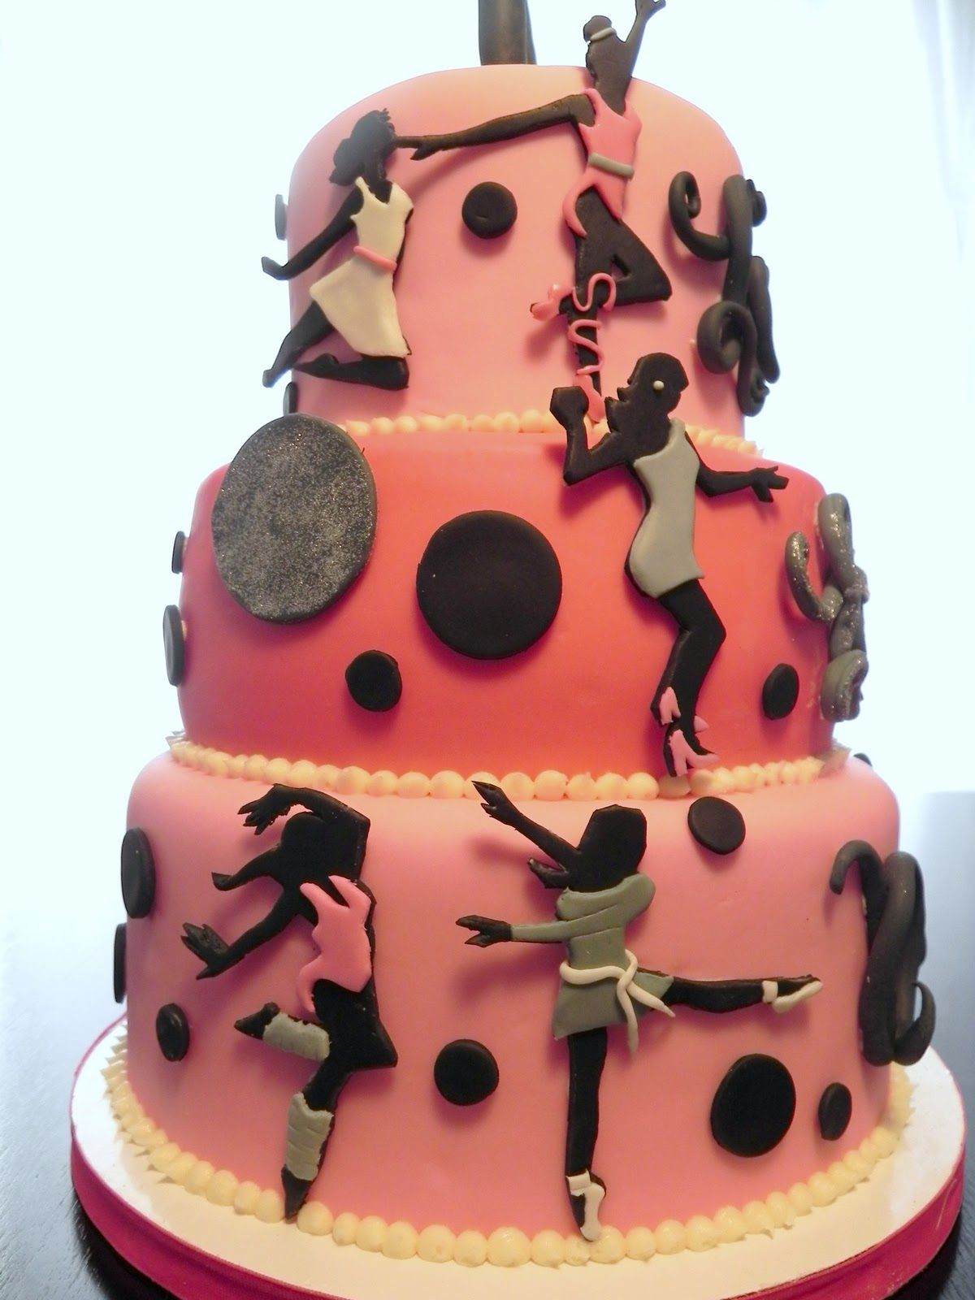
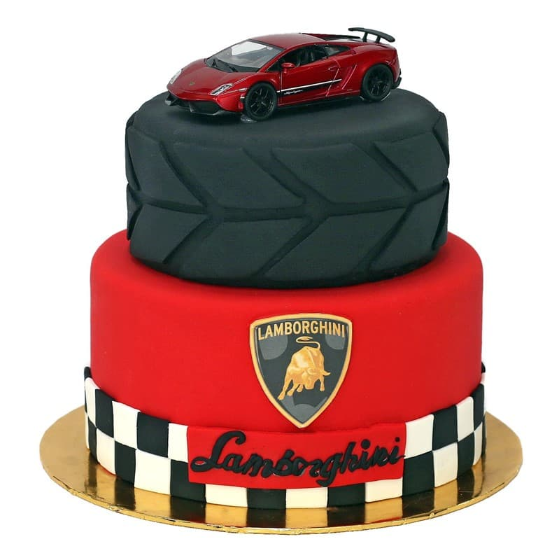
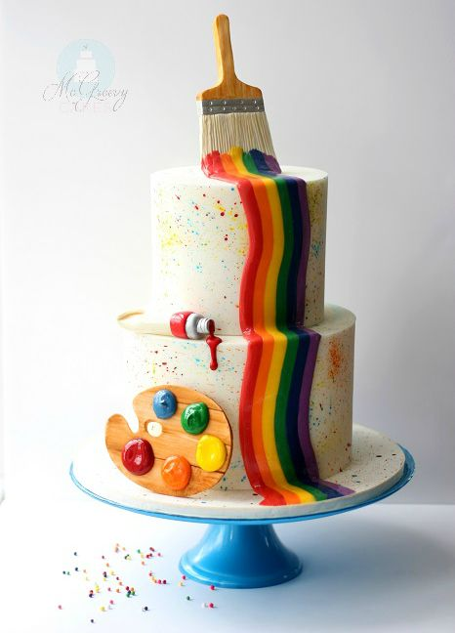

Name: ____________________ Teacher: ________________________

